10.27: a)
or 0.309 rad/s to three figures.
b) 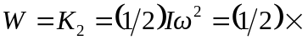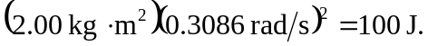
c)

